# TreeEditor

https://github.com/ld4mbse/linkeddata-tree-editor.git



# How to contact developers

Axel Reichwein [axel.reichwein@koneksys.com](mailto:axel.reichwein@koneksys.com)



1390 Market St, Suite 1806,

San Francisco,

CA 94102, USA

Phone: +1 404-590-9211

<http://koneksys.com>

**Table of Contents**

TreeEditor 1

How to contact developers 2

Installation 4

Clone GIT project 4

Install Node.js 4

Install Ruby 5

Install Python 6

Install Visual Studio VC++ 2015 (only on Windows) 7

Run Apache Jena Fuseki2 with a simple server installation 8

Install TreeEditor components 9

Run TreeEditor WebApp 9

Using TreeEditor Client 10

Open Tree Viewer Client 10

Install Model Example 11

Editing block name 12

Adding new block 12

Deleting block with non-cascade mode 13

Deleting block with cascade mode 13

Changing parent block with drag and drop 13

### Installation

1. **Clone TreeEditor project**
2. **Install Node.js**
3. **Install Ruby**
4. **Instal Python 2.7.x**
5. **Run Apache Jena Fuseki2 with a simple server installation**
6. **Install TreeEditor components**
7. **Run TreeEditor WebApp**

Clone GIT project

The recommend GIT branch is “master”. You can get the master branch automatically with the following GIT clone command line. However, if you use GIT user interface version, please select “master” in branch selection.

|  |
| --- |
| **$ git clone https://github.com/ld4mbse/linkeddata-tree-editor.git**  **$ cd linkeddata-tree-editor/edu.gatech.app.treeeditor** |

Install Node.js

If you already have Node.js installed on your machine and Node.js version is not 0.12.7, we recommend you uninstall it and reinstall with Node.js 0.12.7 which is fully tested by developers. By uninstalling Node.js, you will also uninstall the package manager npm. The newer Node.js version higher than 0.12.7 is not tested by developers. Please avoid using different Node.js version. You can check version of Node.js and its package manager with following commands:

|  |
| --- |
| **$ node -v**  **v0.12.7**  **$ npm -v**  **2.11.3** |

The recommended Node.js version is v0.12.7. For a Windows user, the installer can be found at <https://nodejs.org/download/release/v0.12.7/node-v0.12.7-x86.msi> and other OS platforms can check the installation at <https://nodejs.org/download/release/v0.12.7/>

Install Ruby

The recommended Ruby version is v2.3.3. For a Windows user, the Ruby installer for Windows OS can be found at <http://dl.bintray.com/oneclick/rubyinstaller/rubyinstaller-2.2.3.exe>

|  |
| --- |
| **$ ruby -v**  **ruby 2.2.3p173** |

For Windows:

When installing Ruby, add Ruby executables to PATH environment variable (as shown below), to access the Ruby installation from everywhere.

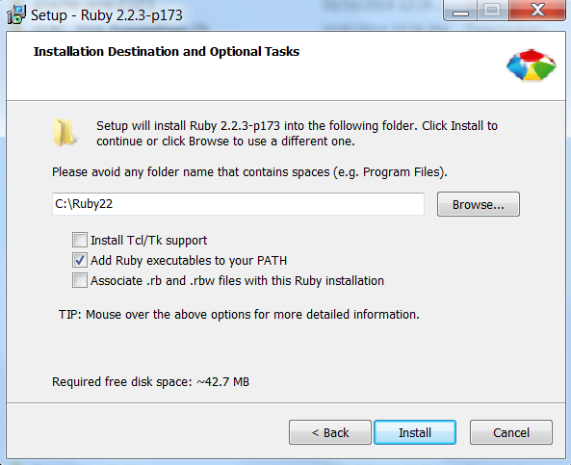

Install Python

The recommended Python version is v2.7.11. For a Windows user, the Python installer for Windows OS can be found at <https://www.python.org/downloads/release/python-2711/>

You must set path of Python installation folder to your PATH environment variable for a Windows computer.

1. [Right Click]Computer > Properties >Advanced System Settings > Environment Variables
2. Locate the "Path" System variable and click
3. Add the your Python installation folder path to the existing variable

|  |
| --- |
| **$ python**  **Python 2.7.11** |

For Windows:

* check if you have already installed Python on your Windows machine by typing ”python -V” in the command prompt window. Launch the command prompt by clicking on Start->All Programs-> Accessories-> Command Prompt
* check your active Python interpreter on your Windows machine by typing ”which python” in the command prompt window.

If your active Python interpreter is different than v2.7.11:

* set the PATH environment variable such that it first refers to the python distribution of v2.7.11 before any other Python distribution
* set the PYTHON_HOME environment variable to point to the python distribution of v2.7.11

If the installation of Python v2.7.11 is blocked, as shown below, re-install it but de-select pip from the install options (<http://stackoverflow.com/questions/23349957/solving-install-issues-with-python-3-4-on-windows/23350061#23350061>)

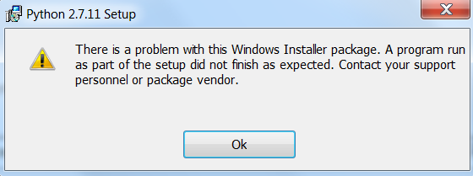

Install Visual Studio VC++ 2015 (only on Windows)

You have to install C++ compiler for Windows OS and the recommended compiler is MS VC++. To install Visual Studio Community Edition, You can download them here

<http://www.visualstudio.com/downloads/download-visual-studiovs>

While you open the installer, you must choose “Custom” and manually select those items: Programing Languages -> Visual C++ -> Common Tools for Visual C++ 2015.

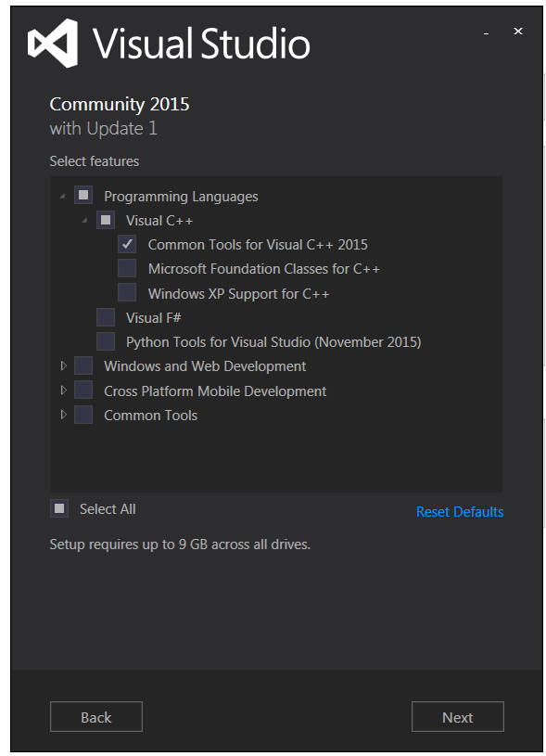

The installation may take several hours. Restart your computer after the installation.

If the installation is stuck, the VC++ compiler may have already been installed on your computer. Just stop the installation process and restart your computer. Additional resources below:

<http://stackoverflow.com/questions/31772347/visual-studio-2015-community-edition-installation-stuck-in-windows-10>

<http://www.howtosolutions.net/2015/08/solving-installation-is-stuck-problem-in-visual-studio-community-edition/#.VomuJfkrJD8>

<http://stackoverflow.com/questions/28983023/visual-studio-2015-ctp6-setup-stuck-on-applying-optional-items>

Run Apache Jena Fuseki2 with a simple server installation

Download Apache Jena Fuseki 2.3.1 or later! Link to download URL: <http://www.eu.apache.org/dist/jena/binaries/apache-jena-fuseki-2.3.1.zip>

Unzip the package. Run the following command in the folder named apache-jena-fuseki-2.3.1:

fuseki-server --update --mem /ds

Example Fuseki start command with a simple server installation. With this command, you will start Fuseki with In-Memory database named /ds and allow Fuseki client modify data.

|  |
| --- |
| **cd C:\apache-jena-fuseki-2.0.0**  **fuseki-server --update --mem /ds** |

For Windows:

* Launch the command prompt by clicking on Start->All Programs-> Accessories-> Command Prompt
* Use the **cd** command to select the apache-jena-fuseki-2.3.1 folder (Example: cd C:\apache-jena-fuseki-2.3.1 (1)\apache-jena-fuseki-2.3.1)
* Run the command **fuseki-server --update --mem /ds**
* To stop the Fuseki server, use CTRL+C

After you successfully start the Fuseki server , the Fuseki admin can be found at <http://localhost:3030>

After you successfully start the Fuseki server , the Fuseki admin can be found at <http://localhost:3030>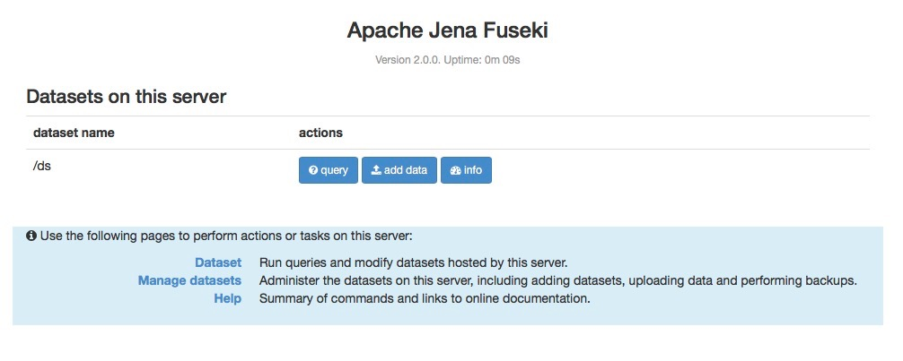

Install TreeEditor components

|  |
| --- |
| **$ cd linkeddata-tree-editor/edu.gatech.app.treeeditor**  **$ npm install** |

|  |
| --- |
| **Common errors on Windows computer**  *ImportError: No module named _multiprocessing*  Python 2.7.x is not found in your PATH environment variable for a Windows computer. You have to install the recommended Python version and complete the PATH environment variable of the installed Python for a Windows computer. Please recheck Python installation in section “Install Python”  *MSBUILD : error MSB4132: The tools version "2.0" is unrecognized. Available tools versions are “4.0”.*  *or Not found “CL.exe”*    You have to install C++ compiler for Windows OS and the recommended compiler is MS VC++. To install Visual Studio Community Edition, You can download them here http://[www.visualstudio.com/downloads/download-visual-studio-vs](http://www.visualstudio.com/downloads/download-visual-studio-vs). While you open the installer, you must choose “Custom” and manually select those items: Customer -> Programing Languages -> Visual C++ -> Common Tools for Visual C++ 2015. After finish the installation, you should have CL.exe program in your VC++ installation folder which is needed to solve above node.js build error. |

Run TreeEditor WebApp

|  |
| --- |
| **$ npm start**  **\*\*\*\*\*\*\*\*\*\*\*\*\*\*\*\*\*\*\*\*\*\*\*\*\*\*\*\*\*\*\*\*\*\*\*\*\*\*\*\*\*\*\*\*\*\*\*\*\*\*\*\*\*\***  **\* TreeEditor \***  **\*\*\*\*\*\*\*\*\*\*\*\*\*\*\*\*\*\*\*\*\*\*\*\*\*\*\*\*\*\*\*\*\*\*\*\*\*\*\*\*\*\*\*\*\*\*\*\*\*\*\*\*\*\***  **TreeEditor client is available at** [**http://localhost:9000**](http://localhost:9000) |

TreeEditor client will be available at <http://localhost:9000>

For Windows:

* To stop the tree editor app, use CTRL+C

### Using TreeEditor Client

* **Open Tree Viewer Client**
* **Install model example**
* **Editing block name**
* **Adding new block**
* **Deleting block with non-cascade mode**
* **Deleting block with cascade mode**
* **Changing parent block with drag and drop**

Open Tree Viewer Client

After you successfully start TreeEditor WebApp with “npm start”, you can view the TreeEditor client with the following URL <http://localhost:9000>

To make sure your Fuseki server is accessible by TreeEditor, you can click “Verify” button in Triplestore tab for verifying the connection to the Fuseki SPARQL and UPDATE endpoint.

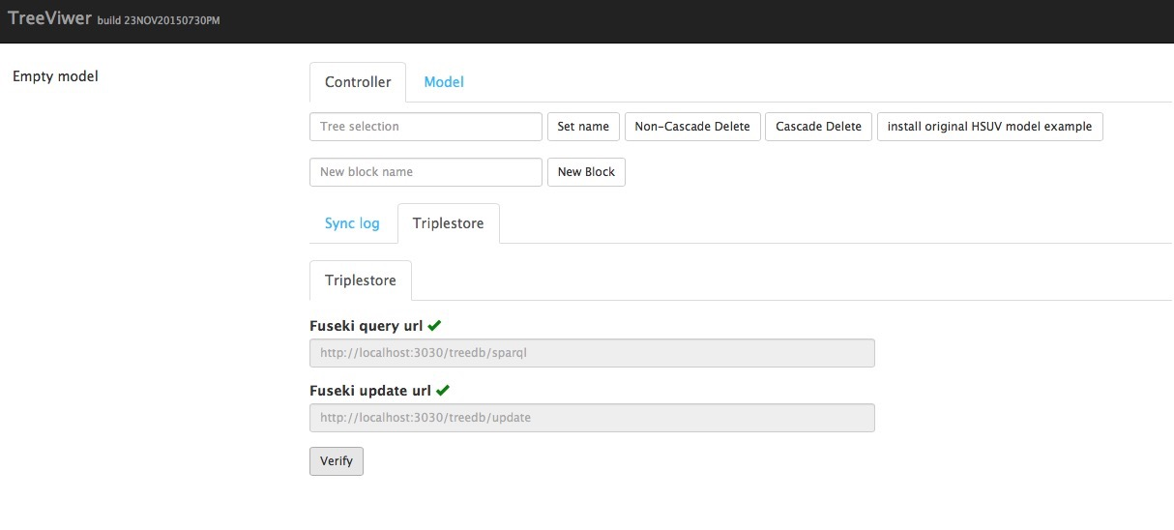

Install Model Example

There is an example model provided for understanding TreeEditor features. You can install the example model by clicking “install original HSUV model example” button in Controller tab.

The HSUV model example will be installed by importing the set of RDF data used to represent this model example with a hierarchical tree structure into the triplestore.

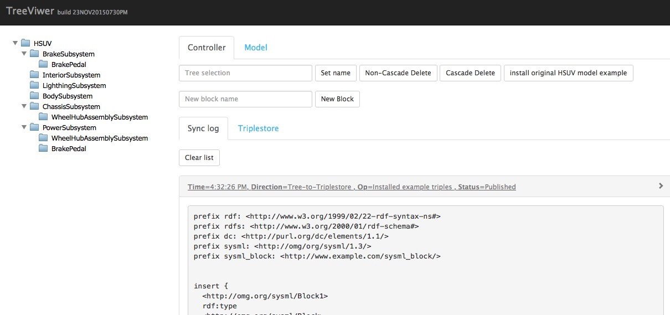

The left side is the model hierarchy of the model example that represented by tree structure. The RDF data of the tree will be expressed with RDF/XML format in Model tab.

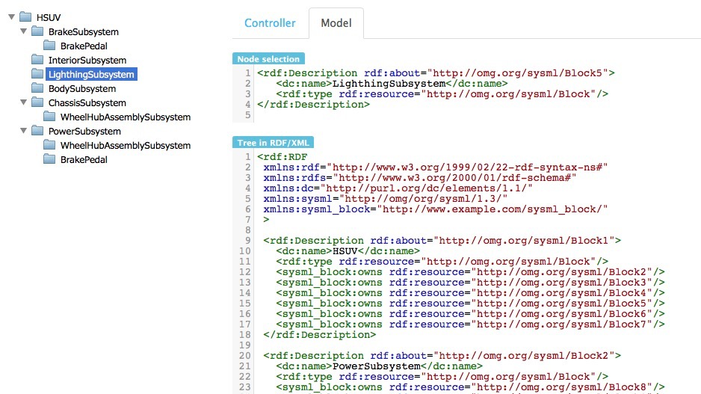

In order to modify the model, there are number of operations provided in Controller tab.

Editing block name

1. Select block to be edited.
2. The block name will be shown in textfield. You can edit the block name and save it by clicking “Set name” button.

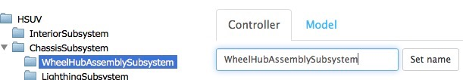

Adding new block

1. The active block in the Controller tab will be a parent block of a new block. If you want to add a new block at the root of the tree, you can empty the textfield or click “Clear and set target level at root” before adding new block.
2. Set name of new block in the new block textfield
3. Resource URI of the new block will be generated automatically by TreeEditor, you can also choose to customize the URI before clicking “New Block” button.
4. Click “New Block” button.

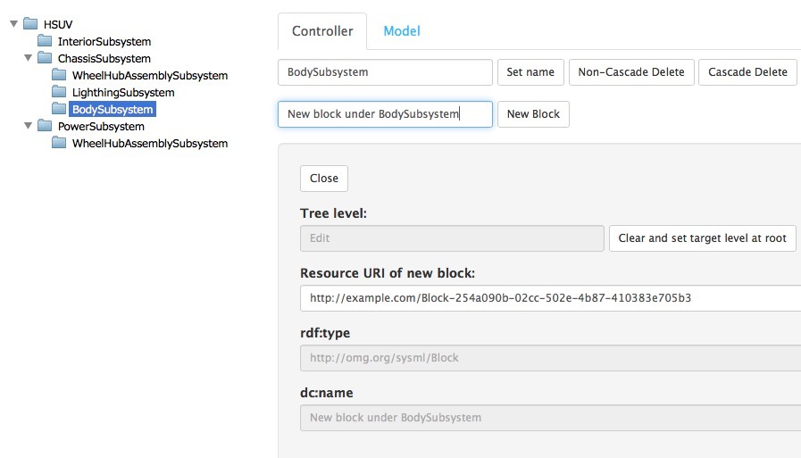

Deleting block with non-cascade mode

Non-cascade deletion mode will delete the selected block only. All child blocks under the selected block will not be deleted.

1. Select block to be deleted.
2. The block name will be shown in textfield. You can delete the block with non-cascade deletion mode by clicking “Non-cascade Delete” button.

With the following figure, if we use non-cascade deletion mode, the ChassisSubsystem block will be deleted and its chid blocks including WheelHubAssemblySubsystem, LightingSubsystem, and BodySubsystem will be free from its parent block. If these three blocks are not under other block, they will be moved the root node of the tree.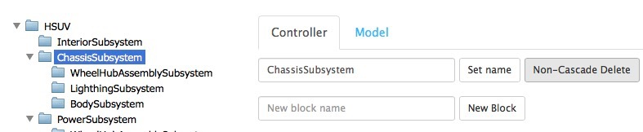

Deleting block with cascade mode

Cascade deletion mode will delete the selected block and its child blocks.

1. Select block to be deleted.
2. The block name will be shown in textfield. You can delete the block with non-cascade deletion mode by clicking “Cascade Delete” button.

With the following figure, if we use cascade deletion mode, the ChassisSubsystem block will be deleted and its chid blocks including WheelHubAssemblySubsystem, LightingSubsystem, and BodySubsystem will be also deleted.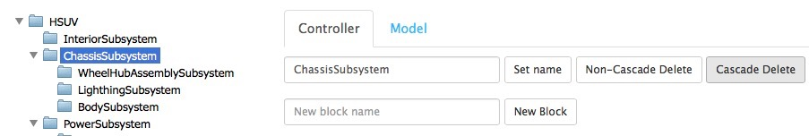

Changing parent block with drag and drop

Each child block node in the tree is draggable. You can change the parent block of a block by drag and drop.